**Polycarbon wind direction transmitter (Analog Type)**

**PR-3000-FXJT-\***

**VER 2.0**



Table of contents

Chapter 1 product introduction

1.1 product overview

1.2 functional characteristics

1.3 main parameters

1.4 system framework diagram

1.5 product selection

Chapter 2 hardware connectivity

2.1 equipment inspection before installation

2.2

2.2.1 sensor wiring

2.3 installation mode

2.4 points to note

Chapter 3 wiring instructions

Chapter 4 the meaning of analog parameter

# Chapter 1 product introduction

## 1.1 product overview

PR-3000-FXJT-* wind direction transmitter, compact and portable, easy to carry and assemble, the new design concept can effectively obtain wind direction information, the shell is made of polycarbonate composite material, with good anti-corrosion, anti-corrosion and other characteristics, anti-exposure, high impact strength, and with the internal smooth bearing system to ensure the accuracy of information collection, traditional analog signals (4 -20 Ma, 0 -10 V, 0 -5 V) are used for data output. It is widely used in greenhouse, environmental protection, weather stations, ships, docks, aquaculture and other environmental wind direction measurement.

## 1.2 functional characteristics

Range: 8 directions

Anti-electromagnetic interference processing

Adopt high-performance imported bearings, small rotational resistance, accurate measurement

Polycarbonate shell, mechanical strength, high hardness, corrosion resistance, non-rust can be used outdoors for a long time

The structure and weight of the equipment are carefully designed and distributed, and the moment of inertia is small and the response is sensitive

The utility model can be applied to four-wire system and three-wire system connection at the same time.

## 1.3 main parameters

|  |  |  |
| --- | --- | --- |
| DC power supply (default) | 10-30 V DC | |
| Maximum power consumption | Current output | 0.75 w |
| Voltage output | 0.75 w |
| Working temperature of transmitter circuit | -20 ° C ~ + 60 ° C, 0% RH ~ 80% Rh | |
| Measuring range | Eight directions | |
| Dynamic response time | ≤0.5 s | |
| Output signal | Current output | 4 ~ 20 ma |
| Voltage output | 0 ~ 5V/0 ~ 10V |
| Load capacity | Voltage output | Output resistance ≤250ω |
| Current output | ≤600 ω |

Product size:

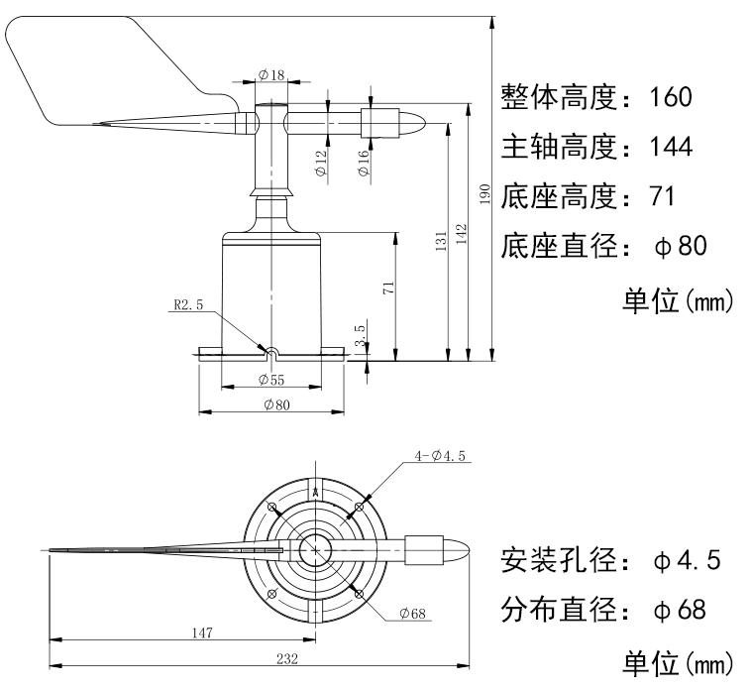

## 1.4 system framework diagram

When the system needs to access an analog version of the sensor, you only need to power the device, while the analog output line into the MCU or PLC DI interface, at the same time, according to the conversion relations of the following preparation of the corresponding acquisition program can be.

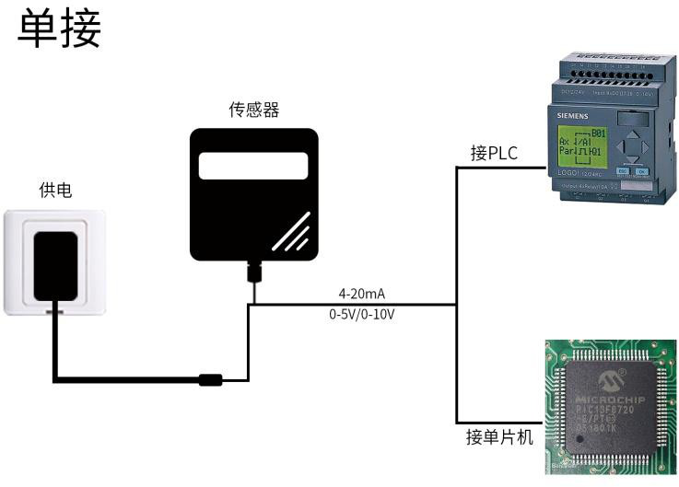

When the system needs to access multiple analog version sensors, each sensor needs to be connected to each different MCU analog data acquisition port or PLC DI interface, at the same time, according to the conversion relations of the following preparation of the corresponding acquisition program can be.

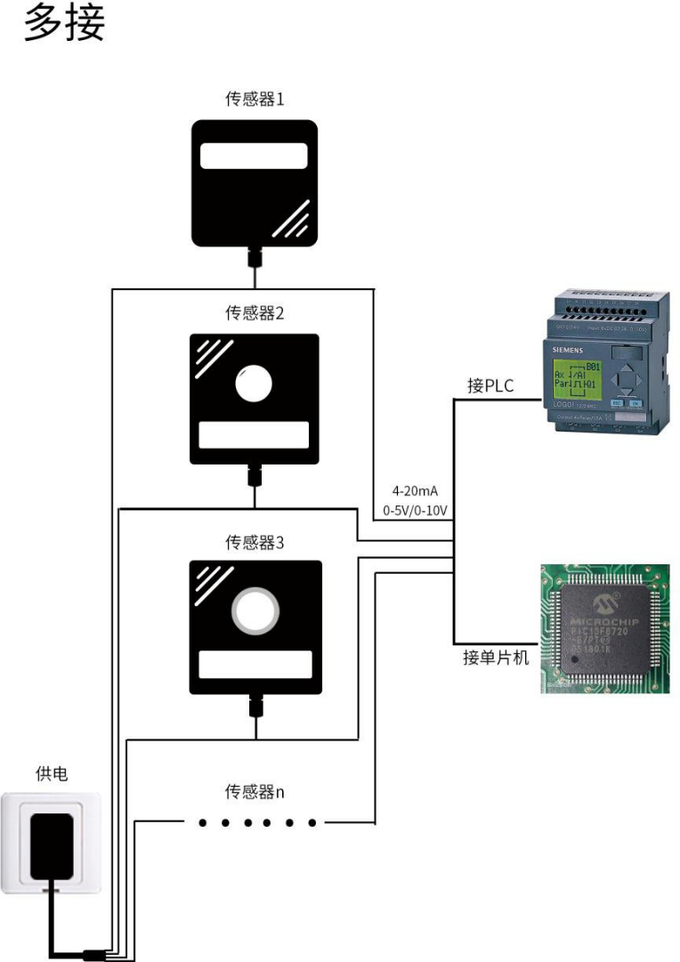

## 1.5 product selection

|  |  |  |  |  |
| --- | --- | --- | --- | --- |
| PR - |  | | | Company code name |
|  | 3000 - |  | | No shell code |
|  | FXJT - |  | Polycarbonate wind direction transmitter |
|  | I 20 - | 4-20ma current output |
| V05 - | 0-5v voltage output |
| V10 | 0-10V voltage output |

# Chapter 2 hardware connectivity

## 2.1 equipment inspection before installation

Equipment list:

1 transmitter equipment

‖ install 4 screws

The Certificate of Conformity and Warranty Card

## 2.2

Wide voltage 10 ~ 30V DC power input. For 0-10V output devices can only use 24V power supply.

### 2.2.1 sensor wiring

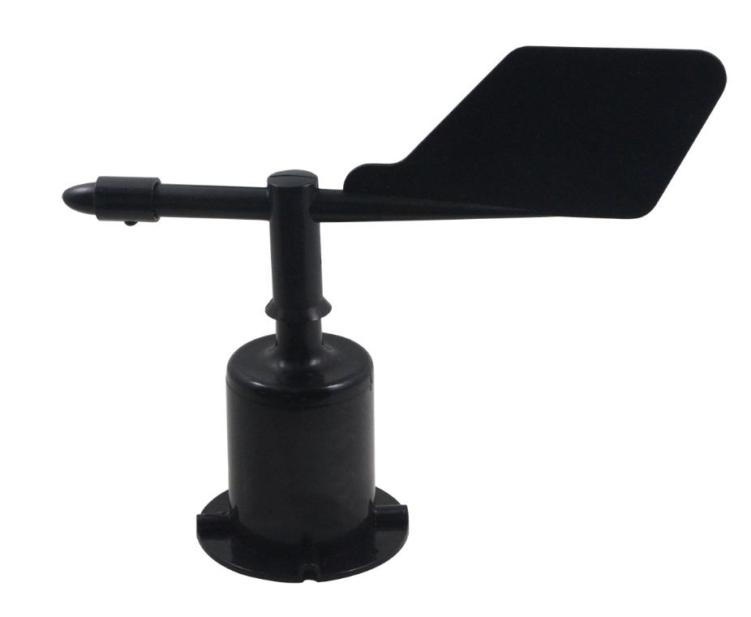

|  |  |  |
| --- | --- | --- |
|  | Line color | Description |
| Power supply | Brown | The power supply is positive |
| Black | The power supply is negative |
| Output | Blue | The wind signal is positive |
| Green | The wind signal is negative |

## 2.3 installation mode

The lower pipe of the wind direction sensor is firmly fixed on the flange plate by means of flange installation and threaded flange connection. The chassis ø80mm is provided with four mounting holes of ø4.5 mm in the circumference of the Ø68MM, use Bolts to fasten it on the bracket, so that the whole set of instruments, to maintain the best level, to ensure the accuracy of wind direction data, flange connection easy to use, can withstand greater pressure.

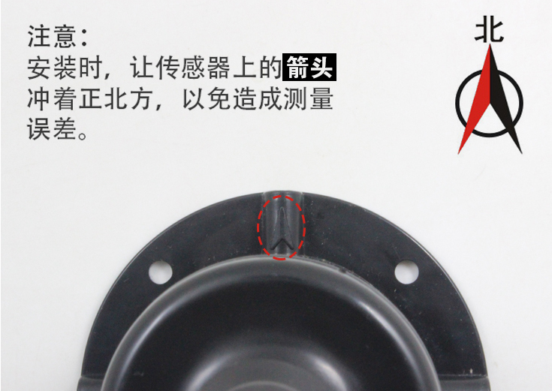

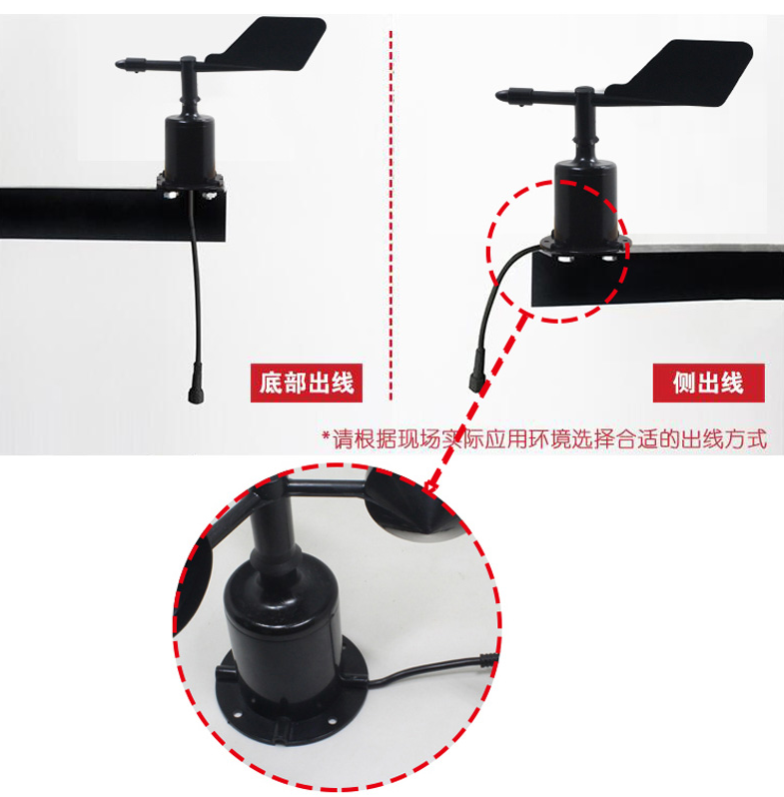

## 2.4 points to note

1. Users are not allowed to disassemble, but also can not touch the sensor core, so as not to cause damage to the product.

2. As far as possible away from high-power interference equipment, so as not to cause inaccurate measurement, such as inverter, motor, etc. .

3. To prevent chemical reagents, oil, dust and other direct damage to the sensor, do not dew, limit temperature environment for long-term use, prevent cold and heat shock

# Chapter 3 wiring instructions

Analog volume sensor wiring is simple, only the wire and the device can be designated port connection. Equipment Standard is with 2 independent analog output. At the same time to adapt to the three-wire system and four-wire system

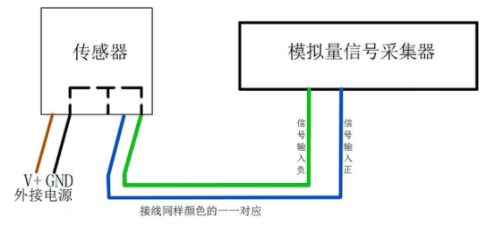

Schematic diagram of four-wire connection method

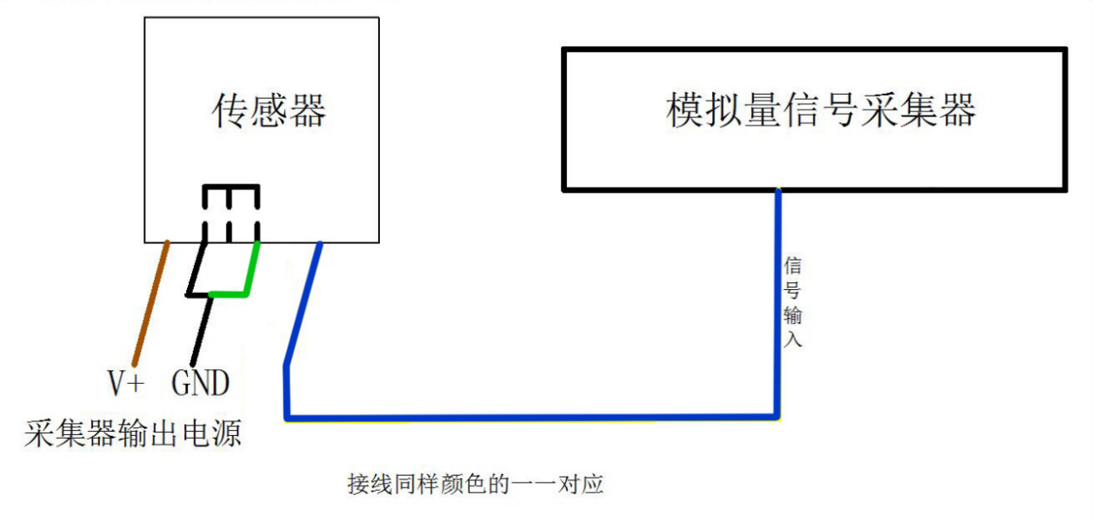

Schematic diagram of three-wire connection method

# Chapter 4 the meaning of analog parameter

|  |  |  |  |  |  |
| --- | --- | --- | --- | --- | --- |
| 4-20mA output control table | | 0-10V output control table | | 0-5V output control table | |
| The output value (Ma) | The wind direction | The output value (V) | The wind direction | The output value (V) | The wind direction |
| ≈4 | North Wind | ≈0 | North Wind | ≈0 | North Wind |
| ≈6.2857 | A northeasterly wind | ≈1.4286 | A northeasterly wind | ≈0.7143 | A northeasterly wind |
| ≈8.5714 | East Wind | ≈2.8571 | East Wind | ≈1.4286 | East Wind |
| ≈10.8571 | Southeast wind | ≈4.2857 | Southeast wind | ≈2.1429 | Southeast wind |
| ≈13.1429 | South wind | ≈5.7143 | South wind | ≈2.8571 | South wind |
| ≈15.4286 | Southwest wind | ≈7.1429 | Southwest wind | ≈3.5714 | Southwest wind |
| ≈17.7143 | West Wind | ≈8.5714 | West Wind | ≈4.2857 | West Wind |
| ≈20 | Northwest wind | ≈10 | Northwest wind | ≈5 | Northwest wind |